Database Systems – Project Brainstorming Activity (Graded)
Business Scenario/Project Name: Railway Management System
Group Members Names, ERP, Section: Muhammad Anas Tabba 28998  Zuhair Merchant 29021  Tayyib Bin Hisham 29087 | Framework: Django/react.js  RDBMS: mysql / oracle

Use Cases:

1. Book a Ticket
Actors: Passenger, System
Description:
- Passenger selects train, travel date, and coach class.
- System checks seat availability.
- Passenger provides personal and contact details.
- System creates a reservation.
- Passenger completes the payment process.
- System confirms the reservation and updates the payment status.

2. Check Train Schedule
Actors: Passenger
Description:
- Passenger searches for trains between two stations for a specific date.
- System returns matching trains with departure and arrival details.

3. View Seat Availability
Actors: Passenger
Description:
- Passenger selects train and class.
- System displays the number of available seats for that class on the selected date.

4. Make Payment
Actors: Passenger
Description:
- Passenger selects a reservation and proceeds to make a payment.
- System processes the payment and updates the status.

5. Modify or Cancel Reservation
Actors: Passenger
Description:
- Passenger logs in and views current reservations.
- Passenger may cancel or modify travel details.
- System updates the reservation status and processes refund if applicable.

6. Calculate Fare
Actors: System
Description:
- System checks the fare for a selected coach and travel date.
- Fare is calculated based on the rate valid for that period.

7. Manage Service Offerings
Actors: Administrator
Description:
- Administrator defines and assigns services to coach classes.
- Services can be scheduled for specific date ranges.

8. Identify Business Days
Actors: System
Description:
- System queries the calendar table to check if a date is a business day.
- This may influence scheduling, fares, or reservation policies.

Business Rules:

Train & Station Rules
- Each train must have one source station and one destination station.
- A station can be associated with multiple trains, either as a source or a destination.

Passenger & Reservation Rules
- Each passenger must have a unique Passenger_ID.
- A passenger can make multiple reservations.
- Each reservation must be linked to exactly one passenger and one coach.
- A reservation must include the date of reservation.

Coach & Class Rules
- Each train consists of one or more coaches.
- Each coach is associated with one coach class (e.g., Sleeper, AC).
- Each coach class defines a capacity and a name.
- A coach is linked to one train and one coach class.

Payment Rules
- Each reservation can have one payment status, indicating whether the ticket has been paid or not.
- Payments include details like amount, due date, and status (paid/unpaid).

Fare & Calendar Rules
- Each coach has a fare based on the date and validity period.
- Fare information is only valid within defined date ranges.
- The calendar identifies whether a given date is a business day.

Service Rules
- The system supports train services (e.g., meals, bedding).
- Services are offered depending on the coach class.
- Service offerings are time-bound and can vary over time.
- Each service must have a unique Service_ID and a descriptive name.

Initial ERD:
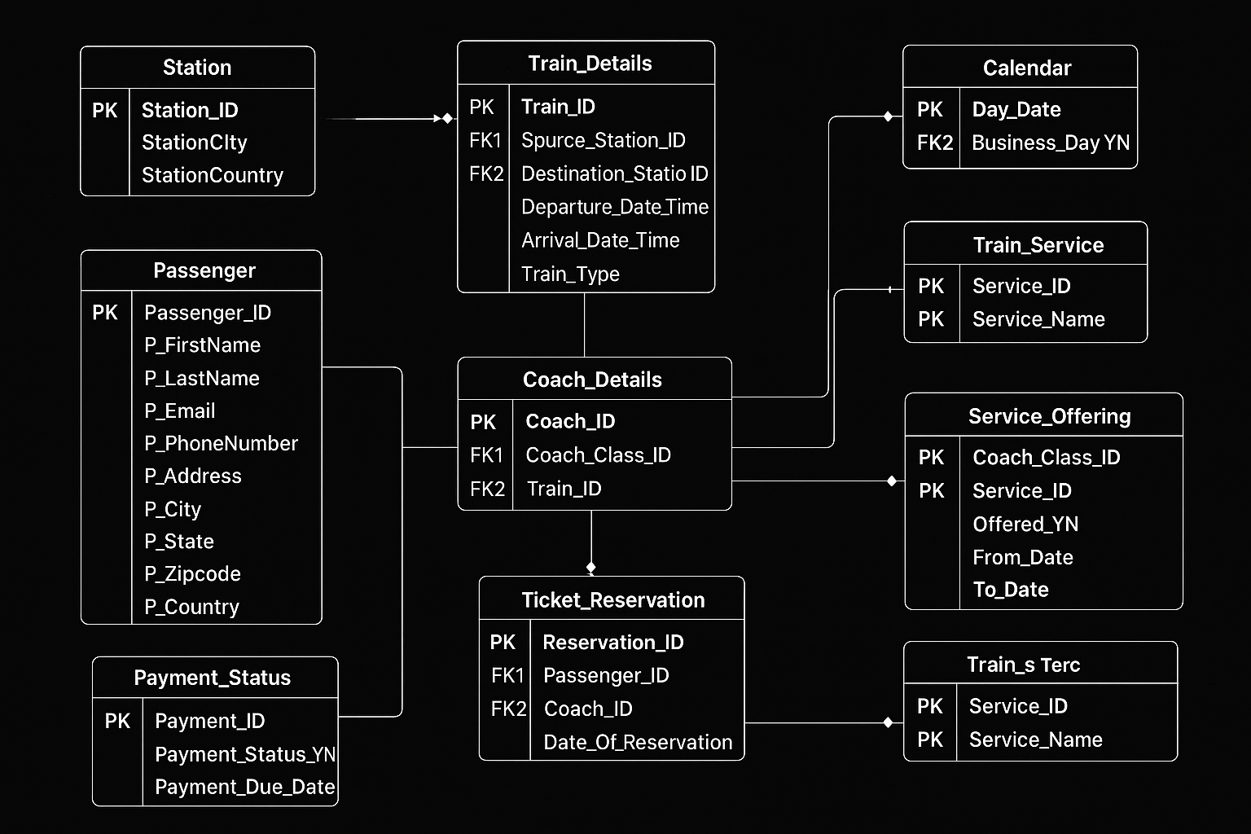

Wireframes: (Initial sketches of your application pages and functionality)

